MICRO PROJECT DOCUMENTATION
Library Management System
Design and development of a digital system for books, members, issue / return and fines
Team Members
- Saksham Seth
- Shubh Asati
- Rajkrishnapal Malviya
Institute: MITS-DU, Gwalior
Platform: Skills Development Monitoring System (SDMS)
Mentor: [Mentor name]

1. Introduction
A library handles hundreds of books and members, and doing this work on paper is slow and error-prone. The Library Management System is a micro project that moves the main library tasks into a simple software system: keeping a catalog of books, registering members, issuing and returning books, and calculating fines for late returns.

2. Problem Statement
Manual registers make it hard to know which books are available, who has taken a book, and when it is due. Late returns are easy to miss and fines are calculated by hand. The project aims to solve these problems with a small, easy-to-use system.

3. Objectives
- Maintain a digital catalog of all books with author, category, ISBN and number of copies.
- Register and manage library members.
- Record every book issue and return with dates.
- Calculate fines automatically for overdue books.
- Allow quick search and simple reports.

4. Scope
The system is meant for a small institute library used by a librarian / admin and students. It covers book management, member management, issue and return, fine calculation, search and basic reports. Online payments and barcode scanning are outside the current scope.

5. Requirements

5.1 Functional requirements
ID | Requirement
FR1 | Add, edit, delete and list books.
FR2 | Register, edit and delete members.
FR3 | Issue a book to a member only if a copy is available.
FR4 | Set the due date automatically (14 days from issue).
FR5 | Record return and calculate the fine if returned after the due date.
FR6 | Search books by title, author or category.
FR7 | Show reports of issued and overdue books.

5.2 Non-functional requirements
- Simple interface that a new user can understand quickly.
- Fast response for search and issue / return actions.
- Data must stay consistent: available copies change correctly on issue and return.

6. System Design

6.1 Architecture
The system has three layers: a user interface for the librarian and students, an application layer that holds the issue / return / fine rules, and a database that stores all records.
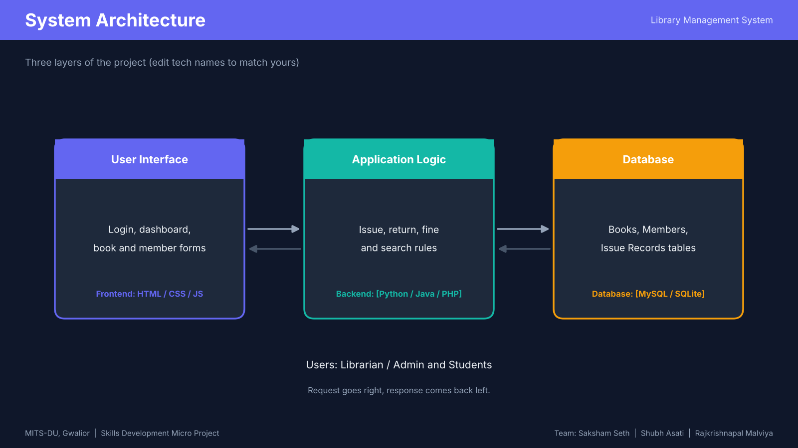

6.2 ER diagram
The database has three entities. One book can appear in many issue records, and one member can have many issue records.
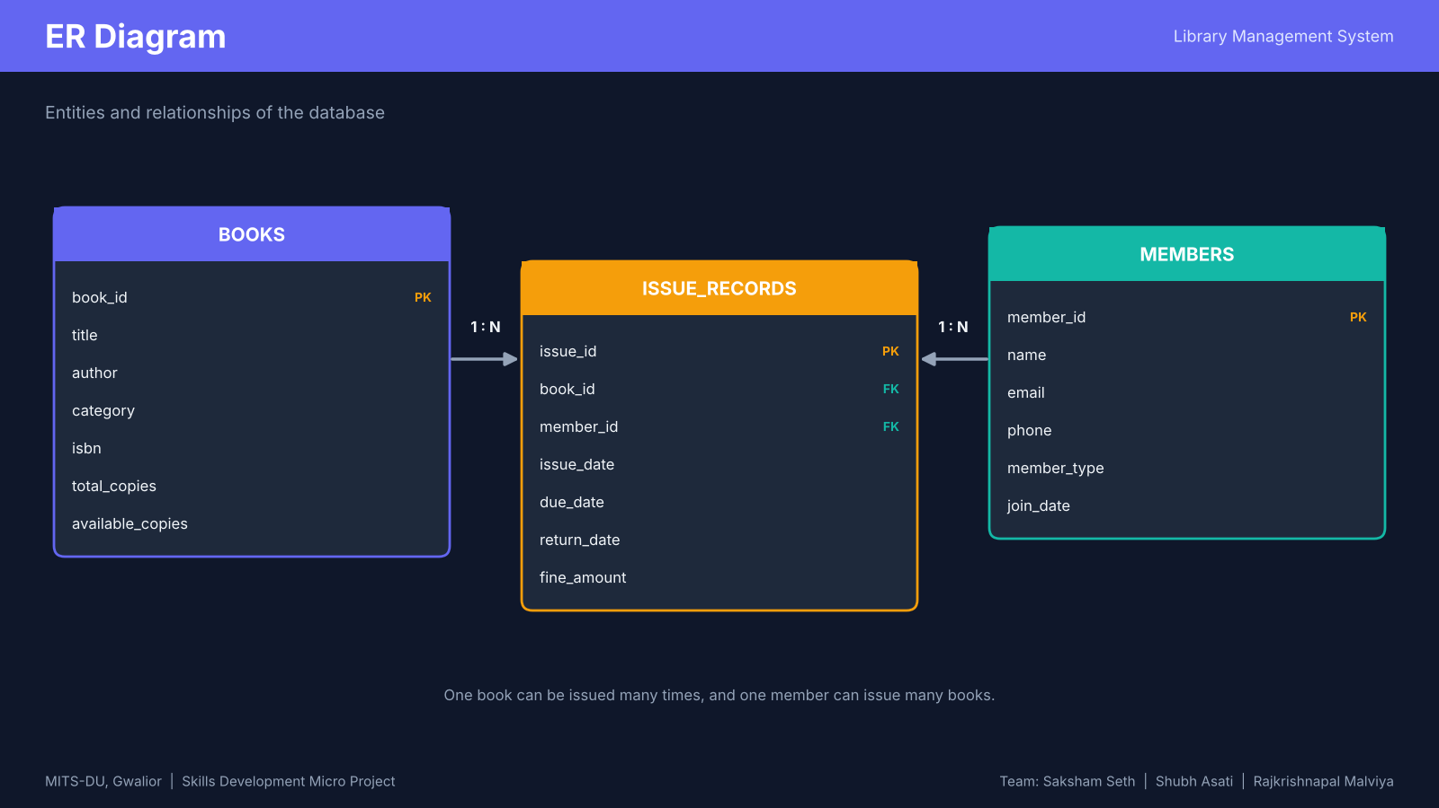

6.3 Database tables
Table | Columns
books | book_id (PK), title, author, category, isbn, total_copies, available_copies
members | member_id (PK), name, email, phone, member_type, join_date
issue_records | issue_id (PK), book_id (FK), member_id (FK), issue_date, due_date, return_date, fine_amount

6.4 Issue and return workflow
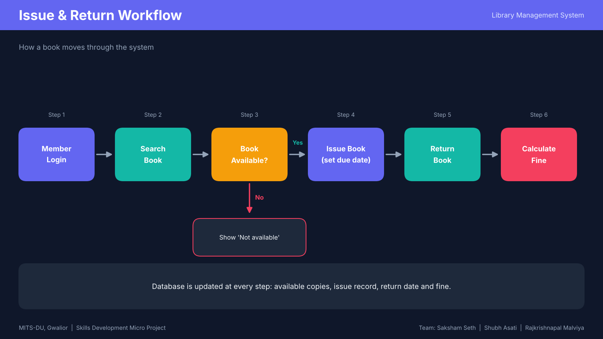
Fine rule used in the project: if a book is returned after the due date, fine = number of late days x Rs 5 per day.

7. Features
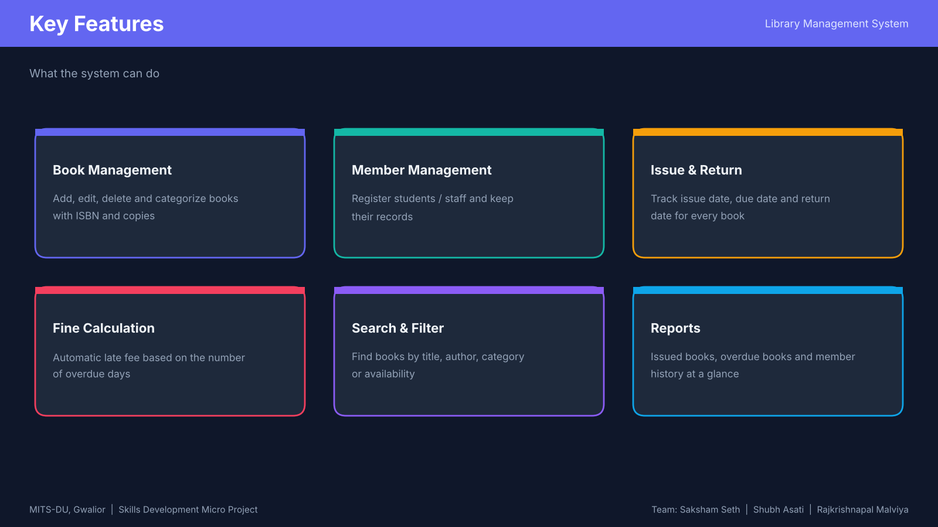

8. Technology Stack
Layer | Technology
Frontend | HTML, CSS, JavaScript
Backend | [Python / Java / PHP / Node.js]
Database | [MySQL / SQLite]
Version control | Git and GitHub

9. Milestones
Milestone | Work | Status
Milestone 1 | Requirement analysis, ER diagram, workflow, wireframes, tech stack finalised, repository set up | Completed
Milestone 2 | Core modules: books, members, issue and return | [In progress / Planned]
Milestone 3 | Fine calculation, search, reports, testing and final documentation | [Planned]

10. Future Scope
- Email or SMS reminders before the due date.
- Barcode / QR code based issue and return.
- Online book reservation for students.
- Dashboard with charts for the librarian.

11. Conclusion
The Library Management System shows how a basic library can be run digitally with a clear database design and simple rules for issue, return and fines. The design is ready to be extended with more features in later milestones.

